Sticky Note & Doodling Reflection

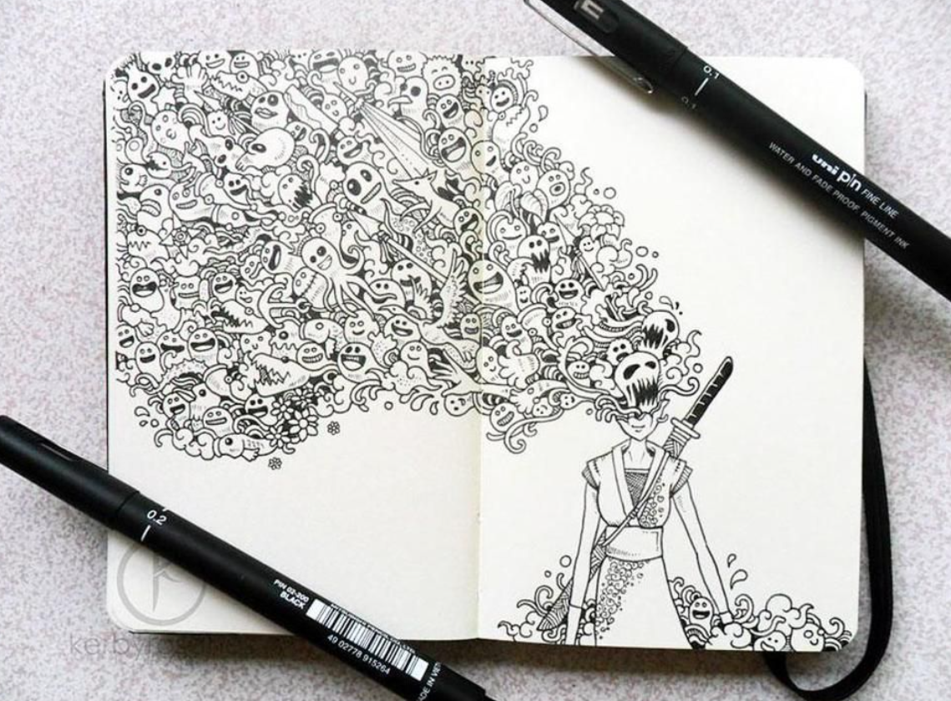

Overview
The sticky note and doodling activity became a simple yet powerful routine that supported both my personal growth and my development as a learner. By capturing short ideas, quick questions, and visual representations of my feelings, I created a safe, low‑pressure space to think. What started as small marks on paper gradually evolved into meaningful insights about how I learn, reflect, and express myself.

My Process
I used sticky notes to record key thoughts, reminders, and emerging understandings. Doodles allowed me to represent emotions, connections, and patterns that were sometimes difficult to put into words. Because each note was small and informal, I felt free to experiment, take risks, and revise my thinking. Over time, I began grouping notes, identifying themes, and turning scattered ideas into structured reflections.

Impact on Personal Growth
This practice strengthened my self‑awareness. I became better at recognizing my emotions, understanding what supports my productivity, and identifying areas where I needed improvement. The visual and creative nature of doodling helped reduce stress and made reflection feel enjoyable rather than intimidating. I noticed growth in my confidence and creativity, as I was able to transform simple thoughts into deeper meaning.

Impact on Professional & Academic Development
The strategy also influenced the way I approach learning tasks and collaboration. I became more focused, organized, and willing to share my ideas. Quick visual notes helped me prepare for discussions, plan projects, and track progress. The routine encouraged independence, responsibility, and a habit of continuous reflection—qualities that are essential for long‑term academic and professional success.

Connection to the IB Learner Profile
Through this activity, I developed attributes that align strongly with the IB Learner Profile:
- Thinker – I analyzed my experiences and experimented with different ways to represent understanding.
- Reflective – I regularly reviewed my thoughts and considered how to improve.
- Risk‑taker – The informal format allowed me to try new ideas without fear of failure.
- Communicator – Visual and written notes helped me express complex feelings and concepts more clearly.
- Balanced – Creative reflection supported my emotional well‑being alongside academic progress.

Connection to Approaches to Learning (ATL) Skills
The sticky note and doodling method naturally strengthened many ATL skill areas:
- Thinking Skills – organizing ideas, making connections, and developing metacognition.
- Self‑Management Skills – improving focus, emotional regulation, and goal setting.
- Communication Skills – expressing understanding through multiple modes (visual and written).
- Research Skills – identifying patterns and evidence in my own learning behaviors.
- Social Skills – becoming more confident when contributing ideas to peers.

Conclusion
Overall, this activity had a meaningful positive impact on my learning journey. It showed me that reflection does not always need to be formal to be powerful. Small, consistent moments of creativity can lead to significant development in confidence, clarity of thought, and personal expression. The habits I built through this practice continue to influence how I learn, collaborate, and grow as a member of both academic and professional communities.

